Design Document Final Version

Productivity web application

Lyutfi Ismail

14.12.2021

Table of Contents

System context 3

Context daigram/ C1 3

Container Diagram and tech choices 4

Container Diagram/ C2 4

Tech CHOICES (Dot framework) 5

Research approach 5

Research methods 6

Components 11

Front-end 11

Back-end/ C3 11

Database Diagram/ ERD 11

Class diagrams (UML) 12

Classdiagrams/ C4 for backend architecture 12

UML of API component (General) 15

5. References 16

# System context

## Context daigram/ C1

# Container Diagram and tech choices

## Container Diagram/ C2

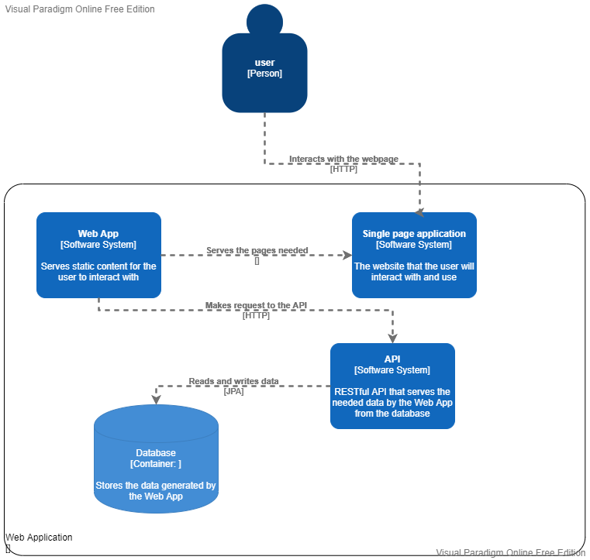

# Tech CHOICES (Dot framework)

### Research approach

Research in ICT aims at creating an ICT product that fits the needs of the client, in this case this product will be a web application that help improve productivity. To help bring structure to the research we will use the DOT framework. The DOT framework has multiple research domains with research strategies that can be used to support the decisions made in a project.

The DOT Framework is a tool that will be used in the research for this project. An overview will be made what method will be used in regard to the research questions

Research question: What technologies are needed to build a full stack web application?

Sub-questions:

1. Which back-end framework can be used to create the RESTful API?
2. Which front-end framework can be used to create a responsive web application?
3. What data storage solution can be used to stare the data generated by the application?

### Research methods

#### Which Back-end framework

1. Library
2. Literature study - We can look through different internet articles to find the best method of implementing a RESTful API.

- What is rest – “A REST API (also known as RESTful API) is an application programming interface (API or web API) that conforms to the constraints of REST architectural style and allows for interaction with RESTful web services. REST stands for representational state transfer and was created by computer scientist Roy Fielding.” [1]

- What is an API – “An API is a set of definitions and protocols for building and integrating application software. It’s sometimes referred to as a contract between an information provider and an information user—establishing the content required from the consumer (the call) and the content required by the producer (the response).” [2]

2. Community research – by looking at the most used and trusted frameworks in the domain, we can find a suitable solution for our use case. That will also help us with providing the most education materials that we can use to expand our knowledge of the framework in the future.

1. Field – but together with the last point, we must consider the full description of the problem
2. Problem analysis – although the overall task required is to develop a full stack application, Fontys has given us some guidelines that the application should adhere to.

- One of the most important guidelines given to us by Fontys was that the application should be developed using the JAVA programming language. That together with the specification that the Spring framework can be used to develop the API, gives us a lot of restriction on the technology used. However, it does help us with the fact that, understanding the subtle difference between the different frameworks is difficult.

1. Conclusion - To build a RESTful API on JAVA, one of the most compelling and popular options is the Spring boot framework. Together with that the main course of the semester will teach this specific framework, so I will have the most knowledge about this framework and together with that, the teachers will be available to help with the development of the API.

#### Which Front-end framework

1. Field
2. Problem analysis - To start off this question, we can go over the requirements presented by Fontys to set a right course for the research.

One of the important requirements was that the app must be a responsive front-end solution. This shows us that we can’t just serve plain HTML, but we also must make everything interactable for the user. Together with that, it is again recommended one specific language should be used – JavaScript.   
These requirements allow us to limit our search to only a few potential candidates that will be researched using the library research method.

1. Library
2. Literature study - We can look through different internet articles to find the best JavaScript based framework for developing a responsive front-end client.
3. Community research – Looking at articles online we can see that the community agrees on some framework, and they are the most widely used. That will also help us with providing the most education materials that we can use to expand our knowledge of the framework in the future.

- React – “Created by Facebook, the React framework has earned popularity within a short period. It is used to develop and operate the dynamic User Interface of the web pages with high incoming traffic. It makes the use of a virtual DOM, and hence, the integration of the same with any application is more straightforward.” [3]

- Angular – “One of the most powerful, efficient, and open-source JavaScript frameworks is Angular. Google operates this framework and is implemented to use for developing a Single Page Application (SPA). It extends the HTML into the application and interprets the attributes to perform data binding.”

- Vue – “Though developed in the year 2016, this JavaScript framework has already made its way into the market and has proven its worth by offering various features. Its dual integration mode is one of the most attractive features for creating high-end SPA or Single Page Application. It is a much reliable platform for developing cross-platform.” [3]

Conclusion - This semester we were introduced to the REACT framework for JavaScript. The main course will follow and teach about this framework.

To maximise the opportunity to learn from the workshop provided and then get the help of the teachers, we will use REACT as the front end of the application.

#### What data storage solution can be used to stare the data generated by the application?

1. Field
2. Problem analysis - To start off this question, we can look at the results of our previous research (especially question 1). To know what data storage solution we need, we must know what is compatible with the back end (restAPI) that we chose.
3. Library – now that we have some limit in our research, we can start looking for data storage solution best suited for the Spring based API solution.
4. Literature study – By looking at article on the subject we can find the different possibilities of implementing a data storage solution for Spring.

- What is a data storage solution – “Data Storage Solutions are required to store the data electronically and making it machine readable. Purpose of these solutions is making data storage and access easy and reliable. The digital data excels in paperless data management.” [4]

Form this source, we can understand that what we need to implement is a data base that will store our user generated data, which we can then access. What we must think about now is the multiple potential Database Management Systems that are available.

“Database Management Systems (DBMS) are software systems used to store, retrieve, and run queries on data. A DBMS serves as an interface between an end-user and a database, allowing users to create, read, update, and delete data in the database.” [5]

1. Community research – Looking at what is widely used, we can see that the community agrees on some DBMS, and they are the most widely used. That will also help us with providing the most education materials that we can use to expand our knowledge of the framework in the future.

1. Conclusion – We will use MySQL for the database and the connection will be managed by the JPA library that the JAVA Spring framework provides.

# Components

## Front-end

## Back-end/ C3

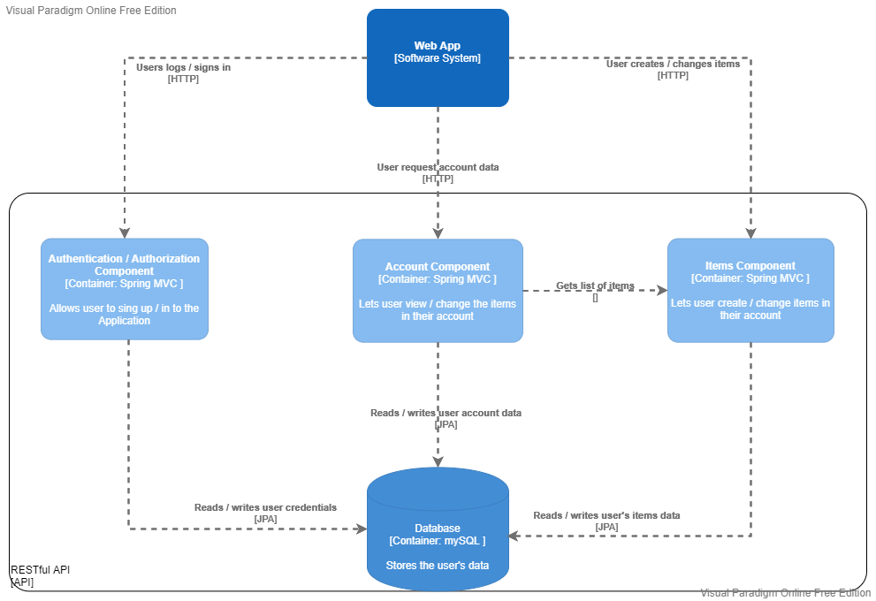

## Database Diagram/ ERD

# Class diagrams (UML)

## Classdiagrams/ C4 for backend architecture

1. 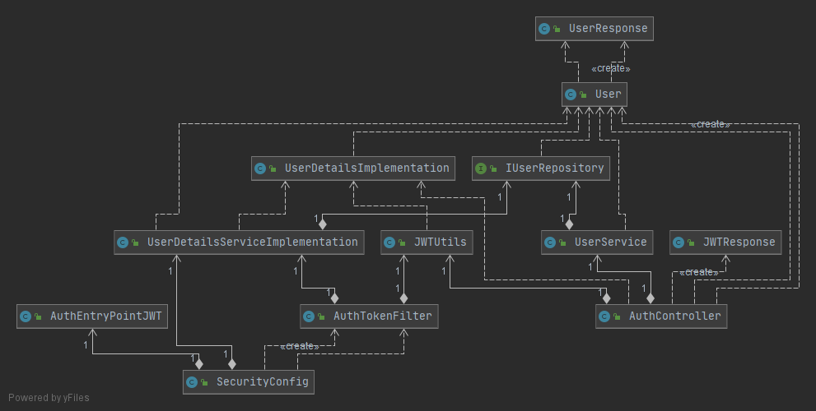Auth/Auth Component

1. 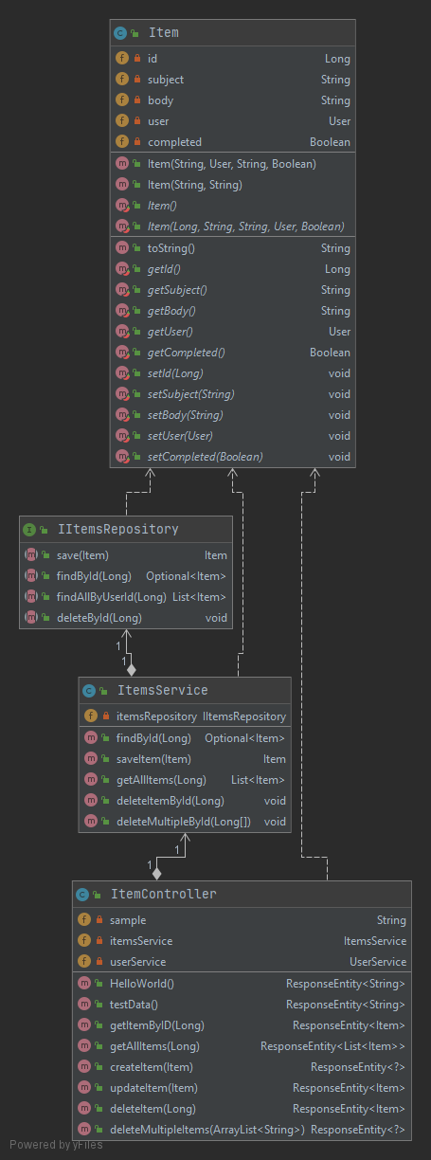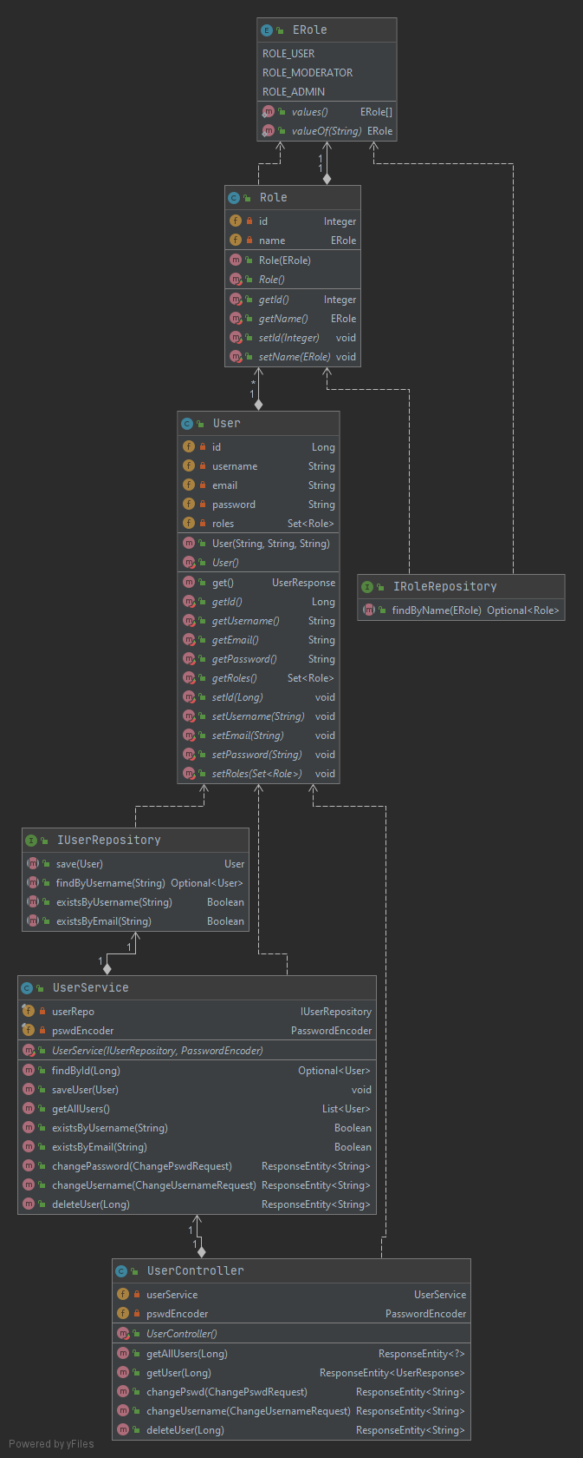Account Component (User) SS 3. Items Component
2. 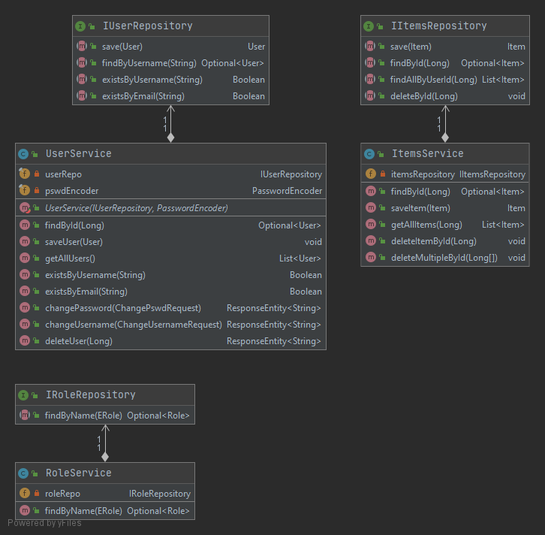Data access layer separation

## UML of API component (General)

# References

1. What is a REST API? (2020, May 8). Https://Www.Redhat.Com/. Retrieved December 14, 2021, from <https://www.redhat.com/en/topics/api/what-is-a-rest-api>
2. What is a REST API? (2020, May 8). Https://Www.Redhat.Com/. Retrieved December 14, 2021, from <https://www.redhat.com/en/topics/api/what-is-a-rest-api>
3. Arora, S. K. (2021, November 21). 10 Best JavaScript Frameworks to Use in 2022. Hackr.Io. Retrieved December 14, 2021, from <https://hackr.io/blog/best-javascript-frameworks>
4. Scott. (2019, February 4). Data Storage Solutions. Www.Colocationamerica.Com. Retrieved December 14, 2021, from <https://www.colocationamerica.com/blog/data-storage-solutions-for-servers>
5. What is DBMS? (n.d.). Www.Appdynamics.Com. Retrieved December 14, 2021, from <https://www.appdynamics.com/topics/database-management-systems>